CO2 Emissions:

It’s effects on global warming and our daily lives

A data visualization by The (Green)Power Rangers

Introduction and Key Facts

Time Trend

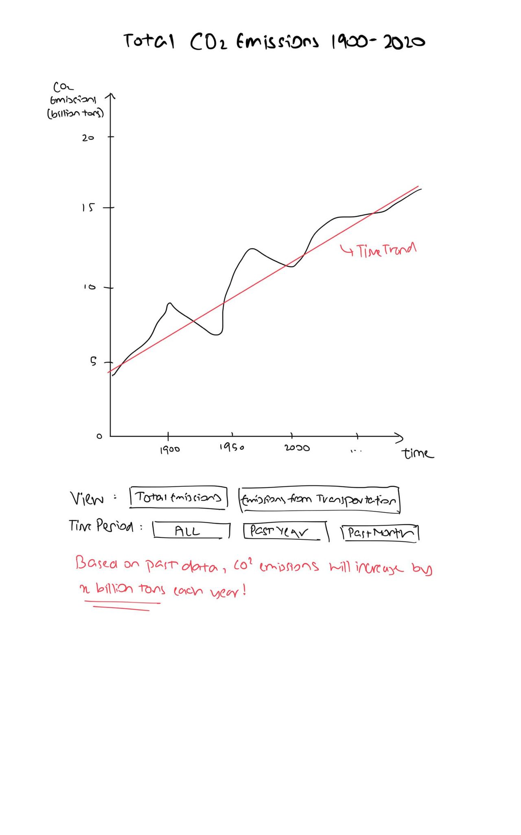

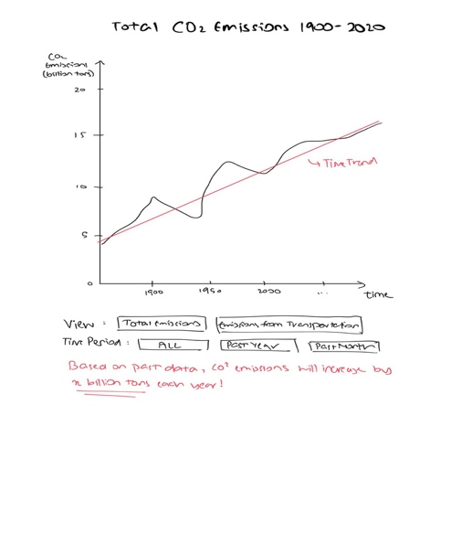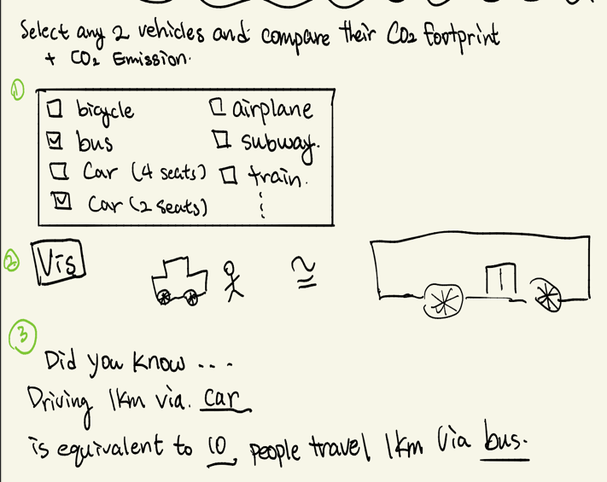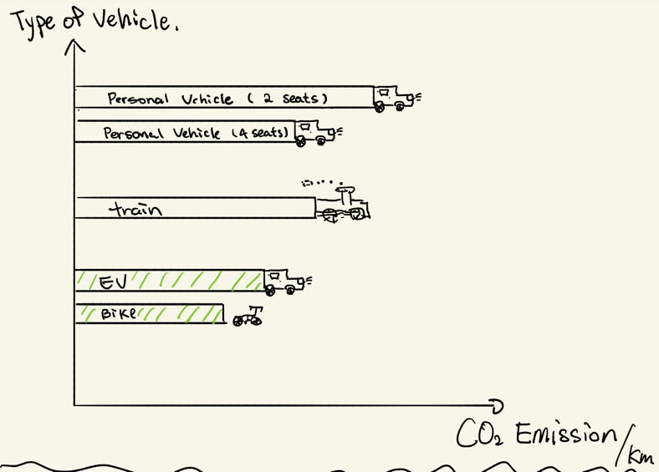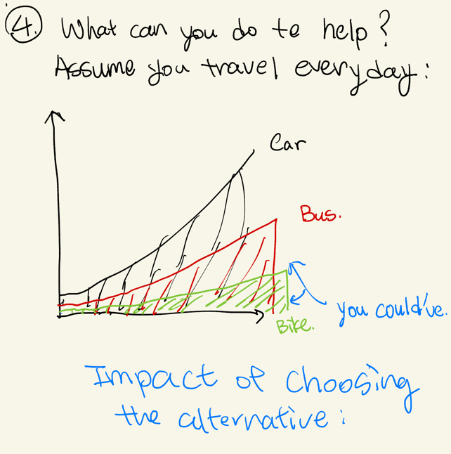

(short conclusion stating how the problem can be solved)

If enough people take steps to reduce emissions caused by transportation, we can potentially reverse climate change…

Conclusion

What can you do to help?

How much do you contribute?